**SALES ANALYTICs**

**Index**

|  |  |  |
| --- | --- | --- |
| s.no | Lesson | pages |
| 1 | objective | 1 |
| 2 | MECE | 12 |
| 3 | Excel | 25 |
| 4 | Power BI | 30 |
| 5 | Summary | 35 |

|  |
| --- |
| pages |

|  |
| --- |
|  |
|  |
|  |
|  |
|  |

**OBJECTIVE**

**The objective of this Power BI report is to provide a comprehensive analysis of sales performance across various dimensions such as products, customers, regions, and time periods. It enables stakeholders to monitor key performance indicators (KPIs) like total sales, revenue growth, and profit margins. The report offers insights into top-selling products, high-performing regions, and customer buying behaviour . Interactive visualizations allow for deep dives into trends and variances, supporting strategic decision-making. By identifying strengths and areas for improvement, the report helps optimize sales operations and drive business growth.**

**Track Sales Performance:**

* **Analyz total revenue, profit, and quantity sold over time.**
* **Compare actuals vs. targets (e.g., monthly/quarterly goals).**

**Monitor Product Performance:**

* **Identify top-selling and least-performing products.**
* **Track sales by product category or brand.**

**Evaluate Customer Behaviour:**

* **Analyz customer segments, order frequency, and lifetime value.**
* **Track customer acquisition and retention trends.**

**Assess Sales by Region/Channel:**

* **Visualize sales performance by geographic region or sales channel.**
* **Identify regions or channels that require strategic focus.**

**Understand Sales Trends Over Time:**

* **Identify seasonal patterns, growth rates, or declining trends.**
* **Forecast future sales based on historical data.**

**Support Decision Making:**

* **Provide actionable insights for marketing, inventory, and sales strategy.**
* **Enable interactive filtering and drill-downs for detailed analysis.**
* **MECE BREAKDOWN**

**1. Sales Analysis**

**1.1. Overall Sales Performance**

* **Total revenue, number of orders, average order value**
* **Sales trends over time (monthly, quarterly, yearly)**

**1.2. Product Performance**

* **Best-selling and least-selling products**
* **Sales by product categories**
* **Profitability and discount impact (from Order Details)**

**1.3. Sales by Region and Channel**

* **Sales distribution by country, city, and region**
* **Shipper performance and freight analysis**

**2. Customer Analysis**

**2.1. Customer Segmentation**

* **Grouping based on sales volume, order frequency, region**
* **New vs. returning customers**

**2.2. Customer behaviour**

* **Purchase patterns (e.g., high seasonality)**
* **Average order size and frequency**

**2.3. Customer Value Metrics**

* **Customer lifetime value (CLV)**
* **Top customers by revenue or frequency**

**3. Employee Performance**

**3.1. Sales by Employee**

* **Total sales handled by each employee**
* **Orders processed and revenue contribution**

**3.2. Performance Over Time**

* **Employee sales growth**
* **Hire date vs. sales impact analysis**

**3.3. Employee Hierarchy**

* **Reporting structure from "Reports To"**
* **Team performance comparison**

**4. Inventory & Product Trends**

**4.1. Stock Management**

* **Units in stock vs. units on order**
* **Reorder level alerts**

**4.2. Discontinued Products**

* **Impact on sales and product lifecycle trends**

**4.3. Category Trends**

* **Performance by product category**
* **Inventory distribution by category**

**5. Operational Insights**

**5.1. Order Fulfillment**

* **Shipping performance (on-time vs. delayed)**
* **Ship via (Shipper efficiency and cost)**

**5.2. Order Details Analysis**

* **Impact of quantity, discount, and unit price on revenue**
* **Order-level profitability**

**6. User Interaction & Design (UI/UX Layer)**

**6.1. Interactive Filters and Slicers**

* **Region, time, category, customer, employee filters**

**6.2. Drill-through Capabilities**

**EDA (EXCEL)**

**1.What are the key factors influencing customer retention or loyalty based on the dataset?**

|  |  |  |  |  |  |
| --- | --- | --- | --- | --- | --- |
| WITH CustomerOrders AS ( | | |  |  |  |
| SELECT |  |  |  |  |  |
| c.CustomerID, | |  |  |  |  |
| COUNT(o.OrderID) AS TotalOrders, | | | |  |  |
| MIN(o.OrderDate) AS FirstOrder, | | | |  |  |
| MAX(o.OrderDate) AS LastOrder | | | |  |  |
| FROM customers c | |  |  |  |  |
| JOIN orders o ON c.CustomerID = o.CustomerID | | | | |  |
| GROUP BY c.CustomerID | | |  |  |  |
| ) |  |  |  |  |  |
| SELECT |  |  |  |  |  |
| CustomerID, | |  |  |  |  |
| TotalOrders, | |  |  |  |  |
| DATEDIFF(LastOrder, FirstOrder) AS DaysBetweenOrders | | | | | |
| FROM CustomerOrders | | |  |  |  |
| WHERE TotalOrders > 1 | | |  |  |  |
| ORDER BY TotalOrders DESC; | | |  |  |  |
|  |  |  |  |  |  |

**OUTPUT:**

|  |  |  |
| --- | --- | --- |
| **CustomersID** | **Totalorders** | **Daysbetweenorders** |
| SAVEA | 31 | 570 |
| ERNSH | 30 | 657 |
| QUICK | 28 | 617 |
| FOLKO | 19 | 642 |
| HUNGO | 19 | 602 |
| BERGS | 18 | 569 |
| RATTC | 18 | 653 |
| HILAA | 18 | 651 |
| BONAP | 17 | 567 |
| FRANK | 15 | 619 |
| LEHMS | 15 | 630 |
| WARTH | 15 | 628 |
| BOTTM | 14 | 490 |
| LAMAI | 14 | 532 |
| KOENE | 14 | 556 |
| WHITC | 14 | 639 |

|  |  |  |
| --- | --- | --- |
|  |  |  |
|  |  |  |
|  |  |  |
|  |  |  |
| |  |  | | --- | --- | |  | **2.How do customer preferences vary based on their location or demographics? Can we explore this through interactive visualizations?** | |  |  |
|  |  |  |

|  |  |  |  |  |  |  |  |  |  |
| --- | --- | --- | --- | --- | --- | --- | --- | --- | --- |
| SELECT |  |  |  |  |  |  |  |  |  |
| cu.Country, | |  | |  | |  | |  | |  |  |  |  |
| p.ProductName, | |  | |  | |  | |  | |  |  |  |  |
| SUM(od.Quantity) AS TotalQuantity | | | |  | | | |  | | |  | | | |  |  |  |
| FROM customers cu | |  | |  | |  | |  | |  |  |  |  |
| JOIN orders o ON cu.CustomerID = o.CustomerID | | | | |  | | | | |  | | | |  | |  | |  |
| JOIN `order details` od ON o.OrderID = od.OrderID | | | | |  | | | | |  | | | |  | |  | |  |
| JOIN products p ON p.ProductID = od.ProductID | | | | |  | | | | |  | | | |  | |  | |  |
| GROUP BY cu.Country, p.ProductName | | | |  | | | |  | | |  | | | |  |  |  |
| ORDER BY cu.Country, TotalQuantity DESC; | | | | |  | | | | |  | | | |  | |  | |  |

**Output:**

|  |  |  |
| --- | --- | --- |
| **Country** | **productname** | **Total quantity** |
| Argentina | Queso Cabrales | 30 |
| Argentina | Rhönbräu Klosterbier | 20 |
| Argentina | Sasquatch Ale | 20 |
| Argentina | Laughing Lumberjack Lager | 20 |
| Argentina | Chef Anton's Gumbo Mix | 20 |
| Argentina | Sir Rodney's Marmalade | 20 |
| Argentina | Boston Crab Meat | 20 |
| Argentina | Ravioli Angelo | 20 |
| Argentina | Sir Rodney's Scones | 17 |
| Argentina | Original Frankfurter grüne Soße | 15 |
| Argentina | Tofu | 12 |
| Argentina | Jack's New England Clam Chowder | 10 |
| Argentina | Röd Kaviar | 10 |
| Argentina | Geitost | 10 |
| Argentina | Lakkalikööri | 10 |

|  |  |  |  |  |  |  |  |
| --- | --- | --- | --- | --- | --- | --- | --- |
|  |  |  |  |  |  |  |  |

**3. Are there any interesting patterns or clusters in customer that can be visualized to identify potential market segments?**

|  |  |  |  |  |  |  |  |  |  |  |  |  |  |  |  |  |  |  |  |  |  |  |  |  |  |  |  |  |  |  |  |  |  |  |  |  |  |  |  |  |  |  |  |  |  |  |  |  |  |  |  |  |  |  |  |  |  |  |  |  |  |  |  |  |  |  |  |  |  |  |  |  |  |  |  |  |  |  |  |  |  |  |  |  |  |  |  |  |  |  |  |  |  |  |  |  |  |  |  |
| --- | --- | --- | --- | --- | --- | --- | --- | --- | --- | --- | --- | --- | --- | --- | --- | --- | --- | --- | --- | --- | --- | --- | --- | --- | --- | --- | --- | --- | --- | --- | --- | --- | --- | --- | --- | --- | --- | --- | --- | --- | --- | --- | --- | --- | --- | --- | --- | --- | --- | --- | --- | --- | --- | --- | --- | --- | --- | --- | --- | --- | --- | --- | --- | --- | --- | --- | --- | --- | --- | --- | --- | --- | --- | --- | --- | --- | --- | --- | --- | --- | --- | --- | --- | --- | --- | --- | --- | --- | --- | --- | --- | --- | --- | --- | --- | --- | --- | --- | --- |
| **3. Are there any interesting patterns or clusters in customer behaviour that can be visualized to identify**  **potential market segments?**       |  |  |  |  |  |  |  | | --- | --- | --- | --- | --- | --- | --- | | WITH RFM AS ( | |  |  |  |  |  | | SELECT | |  |  |  |  |  | | c.CustomerID, | | |  |  |  |  | | DATEDIFF(CURDATE(), MAX(o.OrderDate)) AS Recency, | | | | | | | | COUNT(o.OrderID) AS Frequency, | | | | |  |  | | ROUND(SUM(od.UnitPrice * od.Quantity * (1 - od.Discount)), 2) AS Monetary | | | | | | | | FROM customers c | | |  |  |  |  | | JOIN orders o ON c.CustomerID = o.CustomerID | | | | | |  | | JOIN `order details` od ON o.OrderID = od.OrderID | | | | | |  | | GROUP BY c.CustomerID | | |  |  |  |  | | ) |  |  |  |  |  |  | | SELECT * |  |  |  |  |  |  | | FROM RFM | |  |  |  |  |  | | ORDER BY Monetary DESC; | | |  |  |  |  | |  |

**Output:**

|  |  |  |  |
| --- | --- | --- | --- |
| **CustomersID** | **Recency** | **Frequency** | **Monetory** |
| QUICK | 10597 | 86 | 110277.3 |
| ERNSH | 10576 | 102 | 104874.98 |
| SAVEA | 10580 | 116 | 104361.95 |
| RATTC | 10575 | 71 | 51097.8 |
| HUNGO | 10581 | 55 | 49979.9 |
| HANAR | 10584 | 32 | 32841.37 |
| KOENE | 10595 | 39 | 30908.38 |
| FOLKO | 10584 | 45 | 29567.56 |
| MEREP | 10763 | 32 | 28872.19 |
| WHITC | 10580 | 40 | 27363.6 |
| FRANK | 10602 | 48 | 26656.56 |
| QUEEN | 10577 | 40 | 25717.5 |
| BERGS | 10638 | 52 | 24927.58 |
| SUPRD | 10590 | 39 | 24088.78 |

**4. Are there any specific product categories or SKUs that contribute significantly to order revenue? Can we identify them through visualizations?**

|  |  |  |  |  |  |  |  |
| --- | --- | --- | --- | --- | --- | --- | --- |
| SELECT |  |  |  |  |  |  |  |
| p.ProductName, | | |  |  |  |  |  |
| ROUND(SUM(od.UnitPrice * od.Quantity * (1 - od.Discount)), 2) AS TotalRevenue | | | | | | | |
| FROM `order details` od | | |  |  |  |  |  |
| JOIN products p ON od.ProductID = p.ProductID | | | | | |  |  |
| GROUP BY p.ProductName | | |  |  |  |  |  |
| ORDER BY TotalRevenue DESC | | | |  |  |  |  |
| LIMIT 10; | |  |  |  |  |  |  |

**Output:**

|  |  |
| --- | --- |
| **ProductName** | **TotalRevenue** |
| Cote de Blaye | 141396.73 |
| Thüringer Rostbratwurst | 80368.67 |
| Raclette Courdavault | 71155.7 |
| Tarte au sucre | 47234.97 |
| Camembert Pierrot | 46825.48 |
| Gnocchi di nonna Alice | 42593.06 |
| Manjimup Dried Apples | 41819.65 |
| Alice Mutton | 32698.38 |
| Carnarvon Tigers | 29171.87 |
| Rössle Sauerkraut | 25696.64 |

5.Are there any correlations between order size and customer demographics or product categories?

|  |  |  |  |  |  |  |  |  |  |  |  |  |
| --- | --- | --- | --- | --- | --- | --- | --- | --- | --- | --- | --- | --- |
| WITH OrderValues AS ( | | | |  | |  | |  | |  | | |
| SELECT | |  |  |  | |  | |  | |  | | |
| cu.Country, | | |  |  | |  | |  | |  | | |
| cat.CategoryName, | | | |  | |  | |  | |  | | |
| (od.UnitPrice * od.Quantity * (1 - od.Discount)) AS OrderValue | | | | | | | | | | | | |
| FROM customers cu | | | |  | |  | |  | |  | | |
| JOIN orders o ON cu.CustomerID = o.CustomerID | | | | | | | |  | |  | | |
| JOIN `order details` od ON o.OrderID = od.OrderID | | | | | | | |  | |  | | |
| JOIN products p ON od.ProductID = p.ProductID | | | | | | | |  | |  | | |
| JOIN categories cat ON p.CategoryID = cat.CategoryID | | | | | | | | | |  | | |
| ) | |  |  |  | |  | |  | |  | | |
| SELECT | |  |  |  | |  | |  | |  | | |
| Country, | | |  |  | |  | |  | |  | | |
| CategoryName, | | |  |  | |  | |  | |  | | |
| ROUND(AVG(OrderValue), 2) AS AvgOrderValue | | | | | | | |  | |  | | |
| FROM OrderValues | | |  |  | |  | |  | |  | | |
| GROUP BY Country, CategoryName | | | | | |  | |  | |  | | |
| ORDER BY Country, AvgOrderValue DESC; | | | | | |  | |  | |  | | |
|  | | | | |  | |  | |  | | |
|  | |  | |  |  | |  | |  | | |
| output:     |  |  |  | | --- | --- | --- | | **Country** | **CategoryName** | **Avg order value** | | Argentina | Grains/Cereals | 390 | | Argentina | Condiments | 302.33 | | Argentina | Produce | 284.75 | | Argentina | Confections | 266.89 | | Argentina | Beverages | 256.86 | | Argentina | Dairy Products | 190.58 | | Argentina | Seafood | 121.3 | | Austria | Produce | 1457.85 | | Austria | Meat/Poultry | 1082.16 | | Austria | Beverages | 1059.88 | | Austria | Dairy Products | 1040.99 | | Austria | Grains/Cereals | 968.51 | | Austria | Confections | 966.74 | | Austria | Condiments | 952.33 | | Austria | Seafood | 778.19 | | | | |  |  | |  | |  | | |
|  | | | | | | |  | |  | | |
|  | | | | | | |  | |  | | |
| 6. How does order frequency vary across different customer segments? | | | | | | |  | |  | | |
| |  |  |  |  |  |  | | --- | --- | --- | --- | --- | --- | | SELECT |  |  |  |  |  | | cu.Country, | |  |  |  |  | | COUNT(o.OrderID) AS OrderCount | | | |  |  | | FROM customers cu | | |  |  |  | | JOIN orders o ON cu.CustomerID = o.CustomerID | | | | | | | GROUP BY cu.Country | | |  |  |  | | ORDER BY OrderCount DESC; | | | |  |  | |  |  |  |  |  |  | | | | |  |  | |  | |  | | |
|  | | | | | | | | |  | | |
| Output : | | | | |  | |  | |  | | |
|  | |  | |  |  | |  | |  | | |
| |  |  | | --- | --- | | **country** | **ordercount** | | Germany | 122 | | USA | 122 | | Brazil | 83 | | France | 77 | | UK | 56 | | Venezuela | 46 | | Austria | 40 | | Sweden | 37 | | Canada | 30 | | Mexico | 28 | | Italy | 28 | | Spain | 23 | | Finland | 22 | | Ireland | 19 | | |  | |  |  | |  | |  | | |
|  | | | |  |  | |  | |  | | |
| 7.Are there any correlations between employee satisfaction levels and key performance indicators? | | | |  |  | |  | |  | | |
| |  |  |  | | --- | --- | --- | | WITH EmployeeKPIs AS ( | | | | SELECT |  |  | | e.EmployeeID, | |  | | COUNT(o.OrderID) AS TotalOrdersHandled | | | | FROM employees e | | | | LEFT JOIN orders o ON e.EmployeeID = o.EmployeeID | | | | GROUP BY e.EmployeeID | | | | ) |  |  | | SELECT * FROM EmployeeKPIs; | | | | | | | | | | | | | | |
| Output: | | | | |  | |  | |  | | |
| |  |  | | --- | --- | | **EmployeesID** | **Total orders handled** | | 1 | 123 | | 2 | 96 | | 3 | 127 | | 4 | 156 | | 5 | 42 | | 6 | 67 | | 7 | 72 | | 8 | 104 | | 9 | 43 | | | | | |  | |  | |  | | |
|  | | | | |  | |  | |  | | |
|  | |  | |  |  | |  | |  | | |
|  |
|  | 8.How does employee turnover vary across different departments or job roles? | | | | | | | | | |

|  |  |  |  |  |  |
| --- | --- | --- | --- | --- | --- |
|  | WITH EmployeeStats AS ( | | |  |  |
|  | SELECT | |  |  |  |
|  | e.Title AS JobTitle, | | |  |  |
|  | COUNT(*) AS TotalEmployees | | | |  |
|  | FROM employees e | | |  |  |
|  | GROUP BY e.Title | | |  |  |
|  | ) |  |  |  |  |
|  | SELECT * FROM EmployeeStats; | | | |  |
|  |  |  |  |  |  |
|  |  |  |  |  |  |
|  |  |  |  |  |  |
|  |  |  |  |  |  |
|  |  |  |  |  |  |
|  | Output: |  |  |  |  |

|  |  |
| --- | --- |
| **JobTitle** | **Total Employees** |
| Sales Representative | 6 |
| Vice President, Sales | 1 |
| Sales Manager | 1 |
| Inside Sales Coordinator | 1 |

9.Can we identify any patterns or clusters in employee skill sets or qualifications through visualizations?

|  |  |  |  |  |
| --- | --- | --- | --- | --- |
| WITH EmployeeSkills AS ( | | |  |  |
| SELECT | |  |  |  |
| e.EmployeeID, | | |  |  |
| COUNT(*) AS SkillCount | | | |  |
| FROM employees e | | |  |  |
| GROUP BY e.EmployeeID | | | |  |
| ) |  |  |  |  |
| SELECT * FROM EmployeeSkills; | | | |  |
|  |  |  |  |  |
|  |  |  |  |  |
|  |  |  |  |  |
| Output:     |  |  | | --- | --- | | **Employees ID** | **SkillsCount** | | 1 | 1 | | 2 | 1 | | 3 | 1 | | 4 | 1 | | 5 | 1 | | 6 | 1 | | 7 | 1 | | 8 | 1 | | 9 | 1 | |  |  |  |  |

|  |  |  |  |  |  |  |  |  |  |  |  |  |  |  |  |  |  |  |  |  |  |  |  |  |  |  |  |  |  |  |  |  |  |  |  |  |  |  |  |  |  |  |  |  |  |  |  |  |  |  |  |  |  |  |  |  |  |  |  |  |  |  |  |  |  |  |  |  |  |  |  |  |  |  |  |  |  |  |  |  |
| --- | --- | --- | --- | --- | --- | --- | --- | --- | --- | --- | --- | --- | --- | --- | --- | --- | --- | --- | --- | --- | --- | --- | --- | --- | --- | --- | --- | --- | --- | --- | --- | --- | --- | --- | --- | --- | --- | --- | --- | --- | --- | --- | --- | --- | --- | --- | --- | --- | --- | --- | --- | --- | --- | --- | --- | --- | --- | --- | --- | --- | --- | --- | --- | --- | --- | --- | --- | --- | --- | --- | --- | --- | --- | --- | --- | --- | --- | --- | --- | --- |
| 10.Are there any correlations between product attributes (e.g., size, color, features)  and sales performance?     |  |  |  |  |  |  |  | | --- | --- | --- | --- | --- | --- | --- | | SELECT |  |  |  |  |  |  | | p.ProductName, | | |  |  |  |  | | p.QuantityPerUnit, | | |  |  |  |  | | ROUND(SUM(od.UnitPrice * od.Quantity * (1 - od.Discount)), 2) AS TotalRevenue | | | | | | | | FROM products p | |  |  |  |  |  | | JOIN `order details` od ON p.ProductID = od.ProductID | | | | | |  | | GROUP BY p.ProductName, p.QuantityPerUnit | | | | |  |  | | ORDER BY TotalRevenue DESC; | | | |  |  |  | |  |  |  |  |  |  |  | |  |  |  |  |  |  |  | | | | | | | | | | | |
|  |  |  |  |  |  |  |  |  |  |  |

**OUTPUT:**

|  |  |  |
| --- | --- | --- |
| **productname** | **quantityperunit** | **TotalRevenue** |
| Côte de Blaye | 12 - 75 cl bottles | 141396.73 |
| Thüringer Rostbratwurst | 50 bags x 30 sausgs. | 80368.67 |
| Raclette Courdavault | 5 kg pkg. | 71155.7 |
| Tarte au sucre | 48 pies | 47234.97 |
| Camembert Pierrot | 15 - 300 g rounds | 46825.48 |
| Gnocchi di nonna Alice | 24 - 250 g pkgs. | 42593.06 |
| Manjimup Dried Apples | 50 - 300 g pkgs. | 41819.65 |
| Alice Mutton | 20 - 1 kg tins | 32698.38 |
| Carnarvon Tigers | 16 kg pkg. | 29171.87 |
| Rössle Sauerkraut | 25 - 825 g cans | 25696.64 |
| Mozzarella di Giovanni | 24 - 200 g pkgs. | 24900.13 |
| Ipoh Coffee | 16 - 500 g tins | 23526.7 |

11.How does product demand fluctuate over different seasons or months

|  |  |  |  |  |  |
| --- | --- | --- | --- | --- | --- |
| WITH MonthlyRevenue AS ( | | |  |  |  |
| SELECT | |  |  |  |  |
| DATE_FORMAT(o.OrderDate, '%Y-%m') AS Month, | | | | | |
| ROUND(SUM(od.UnitPrice * od.Quantity * (1 - od.Discount)), 2) AS TotalRevenue | | | | | |
| FROM orders o | |  |  |  |  |
| JOIN `order details` od ON o.OrderID = od.OrderID | | | | | |
| GROUP BY Month | | |  |  |  |
| ) |  |  |  |  |  |
| SELECT * |  |  |  |  |  |
| FROM MonthlyRevenue | | |  |  |  |
| ORDER BY Month; | |  |  |  |  |

**OUTPUT:**

|  |  |  |  |  |  |  |  |  |  |  |  |  |  |  |  |  |  |  |  |
| --- | --- | --- | --- | --- | --- | --- | --- | --- | --- | --- | --- | --- | --- | --- | --- | --- | --- | --- | --- |
| |  |  | | --- | --- | | **Month** | **Total Revenue** | | 1994-08 | 27861.89 | | 1994-09 | 25485.27 | | 1994-10 | 26381.4 | | 1994-11 | 35931.72 | | 1994-12 | 47184.04 | | 1995-01 | 45239.63 | | 1995-02 | 52540.24 | | 1995-03 | 47201.46 | | **Total Revenue** |
| 12.Can we identify any outliers or anomalies in product performance or sales using visualizations? | 27861.89 |

|  |  |  |  |  |  |  |  |
| --- | --- | --- | --- | --- | --- | --- | --- |
|  | SELECT |  |  |  |  |  |  |
|  | p.ProductName, | | |  |  |  |  |
|  | SUM(od.Quantity) AS TotalQuantitySold | | | | |  |  |
|  | FROM products p | | |  |  |  |  |
|  | JOIN `order details` od ON p.ProductID = od.ProductID | | | | | | |
|  | GROUP BY p.ProductName | | | |  |  |  |
|  | ORDER BY TotalQuantitySold DESC;  OUTPUT:     |  |  | | --- | --- | | **productname** | **Totalquantitysold** | | Camembert Pierrot | 1577 | | Raclette Courdavault | 1496 | | Gorgonzola Telino | 1397 | | Gnocchi di nonna Alice | 1263 | | Pavlova | 1158 | | Rhönbräu Klosterbier | 1155 | | Guaraná Fantástica | 1125 | | Boston Crab Meat | 1103 |  |  |  |  |  |  |  |  |  |  |  |  |  |  |  |  |  | | --- | --- | --- | --- | --- | --- | --- | --- | --- | --- | --- | --- | --- | --- | --- | --- | | 13.Are there any correlations between supplier attributes (e.g., location, size, industry) and performance metrics (e.g., on-time delivery, product quality)? | | | | | | | | | | | | | | | | |  |  |  |  |  |  |  |  |  |  |  |  |  |  |  |  |      |  |  |  |  |  |  |  |  | | --- | --- | --- | --- | --- | --- | --- | --- | | WITH SupplierPerformance AS ( | | | |  |  |  |  | | SELECT | |  |  |  |  |  |  | | s.CompanyName, | | |  |  |  |  |  | | s.Country, | |  |  |  |  |  |  | | ROUND(SUM(od.UnitPrice * od.Quantity * (1 - od.Discount)), 2) AS Revenue | | | | | | | | | FROM suppliers s | | |  |  |  |  |  | | JOIN products p ON s.SupplierID = p.SupplierID | | | | | |  |  | | JOIN `order details` od ON p.ProductID = od.ProductID | | | | | |  |  | | GROUP BY s.CompanyName, s.Country | | | | |  |  |  | | ) |  |  |  |  |  |  |  | | SELECT * |  |  |  |  |  |  |  | | FROM SupplierPerformance | | |  |  |  |  |  | | ORDER BY Revenue DESC; | | |  |  |  |  |  | |  |  |  |  |  |  |  |  |   OUTPUT:       |  |  |  | | --- | --- | --- | | **Companyname** | **country** | **Revenue** | | Aux joyeux ecclésiastiques | France | 153691.27 | | Plutzer Lebensmittelgroßmärkte AG | Germany | 145372.4 | | Gai pâturage | France | 117981.18 | | Pavlova, Ltd. | Australia | 106459.78 | | G'day, Mate | Australia | 65626.77 | | Forêts d'érables | Canada | 61587.57 | | Pasta Buttini s.r.l. | Italy | 50254.61 | | Formaggi Fortini s.r.l. | Italy | 48225.16 |  |  |  |  |  |  |  |  |  |  | | --- | --- | --- | --- | --- | --- | --- | --- | --- | | 14.How does supplier performance vary across different product categories or departments? | | | | | | | | | |  |  |  |  |  |  |  |  |  |      |  |  |  |  |  |  | | --- | --- | --- | --- | --- | --- | | WITH SupplierPerformance AS ( | | | |  |  | | SELECT | |  |  |  |  | | s.CompanyName, | | |  |  |  | | s.Country, | |  |  |  |  | | ROUND(SUM(od.UnitPrice * od.Quantity * (1 - od.Discount)), 2) AS Revenue | | | | | | | FROM suppliers s | | |  |  |  | | JOIN products p ON s.SupplierID = p.SupplierID | | | | | | | JOIN `order details` od ON p.ProductID = od.ProductID | | | | | | | GROUP BY s.CompanyName, s.Country | | | | |  | | ) |  |  |  |  |  | | SELECT * |  |  |  |  |  | | FROM SupplierPerformance | | |  |  |  | | ORDER BY Revenue DESC; | | |  |  |  | |  |  |  |  |  |  |   OUTPUT:     |  |  |  | | --- | --- | --- | | **Campanyname** | **country** | **Revenue** | | Aux joyeux ecclésiastiques | France | 153691.27 | | Plutzer Lebensmittelgroßmärkte AG | Germany | 145372.4 | | Gai pâturage | France | 117981.18 | | Pavlova, Ltd. | Australia | 106459.78 | | G'day, Mate | Australia | 65626.77 | | Forêts d'érables | Canada | 61587.57 | | Pasta Buttini s.r.l. | Italy | 50254.61 | | Formaggi Fortini s.r.l. | Italy | 48225.16 | | Specialty Biscuits, Ltd. | UK | 46243.98 | | Norske Meierier | Norway | 43141.51 | | Leka Trading | Singapore | 42017.64 | | Grandma Kelly's Homestead | USA | 41953.3 | | | | | |  |  |
|  |  |  |  |  |  |  |  |

|  |  |  |  |  |  |  |  |  |  |  |
| --- | --- | --- | --- | --- | --- | --- | --- | --- | --- | --- |
| 15.Can we identify any trends or patterns in supplier costs or pricing structures through  visualizations? | | | | | | | | | | |
|  |  |  |  |  |  |  |  |  |  |  |

|  |  |  |  |  |  |  |
| --- | --- | --- | --- | --- | --- | --- |
|  | SELECT |  |  |  |  |  |
|  | s.CompanyName, | | |  |  |  |
|  | p.ProductName, | | |  |  |  |
|  | p.UnitPrice | |  |  |  |  |
|  | FROM suppliers s | | |  |  |  |
|  | JOIN products p ON s.SupplierID = p.SupplierID | | | | | |
|  | ORDER BY s.CompanyName, p.UnitPrice DESC; | | | | | |
|  |  |  |  |  |  |  |

**OUTPUT:**

|  |  |  |
| --- | --- | --- |
| **campanyname** | **productname** | **unitprice** |
| Aux joyeux ecclésiastiques | Côte de Blaye | 263.5 |
| Aux joyeux ecclésiastiques | Chartreuse verte | 18 |
| Bigfoot Breweries | Steeleye Stout | 18 |
| Bigfoot Breweries | Laughing Lumberjack Lager | 14 |
| Bigfoot Breweries | Sasquatch Ale | 14 |
| Cooperativa de Quesos 'Las Cabras' | Queso Manchego La Pastora | 38 |
| Cooperativa de Quesos 'Las Cabras' | Queso Cabrales | 21 |
| Escargots Nouveaux | Escargots de Bourgogne | 13.25 |
| Exotic Liquids | Chang | 19 |
| Exotic Liquids | Chai | 18 |
| Exotic Liquids | Aniseed Syrup | 10 |
| Forêts d'érables | Tarte au sucre | 49.3 |
| Forêts d'érables | Sirop d'érable | 28.5 |
| Formaggi Fortini s.r.l. | Mozzarella di Giovanni | 34.8 |
| Formaggi Fortini s.r.l. | Mascarpone Fabioli | 32 |

**POWER BI**

**Author Analysis: The dashboard offers insights into author performance based on book sales, royalties, and genre preferences. It highlights the top-performing authors by revenue and volume, allowing stakeholders to identify valuable contributors. Trends in author popularity over time help forecast future performance and reader interest. This data supports better author engagement and royalty planning for the business.**

**Publishers Analysis: This section focuses on publisher contributions to overall sales, title availability, and market reach. It compares sales figures across publishers, revealing which partnerships drive the highest returns. The dashboard also tracks delivery timelines and regional distribution of publishers. These insights assist in evaluating publisher efficiency and renegotiating contracts for better outcomes.**

**Title Analysis: The dashboard examines individual book titles to determine their sales performance, reader popularity, and contribution to overall revenue. It identifies bestsellers, underperforming titles, and seasonal favorites, enabling more strategic inventory and marketing decisions. Detailed metrics such as units sold, average price, and returns provide a clear picture of each title’s performance. This helps prioritize top titles and plan reprints or discontinuations.**

**Sales Analysis: This section gives a comprehensive overview of sales performance across time, channels, and discount structures. It visualizes monthly, quarterly, and yearly sales trends, offering clarity on growth patterns and peak seasons. The dashboard also explores the impact of discounts and pricing changes on total revenue. These insights help refine the company’s pricing strategy and promotional planning.**

**Store Analysis: The dashboard evaluates store-level performance, tracking metrics such as sales volume, product availability, and regional demand. It identifies high-performing outlets and highlights areas with growth potential. Store comparison helps optimize inventory allocation and improve regional marketing efforts. With this information, the company can enhance store operations and ensure efficient product distribution.**

**ER Diagram**

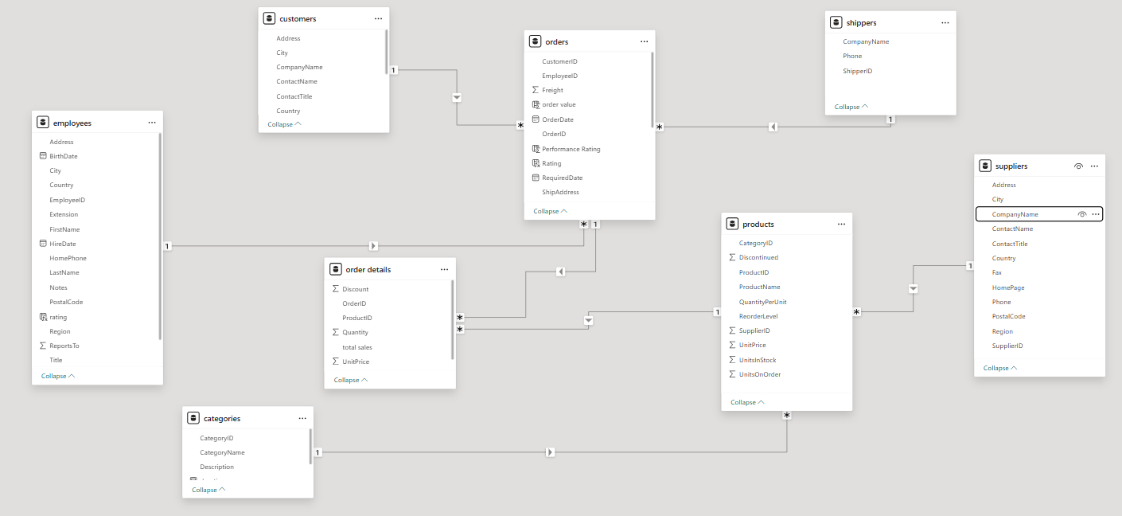

**1.How does customer distribution vary across different regions or customer segments? Can we visualize it on a map or bar chart?**

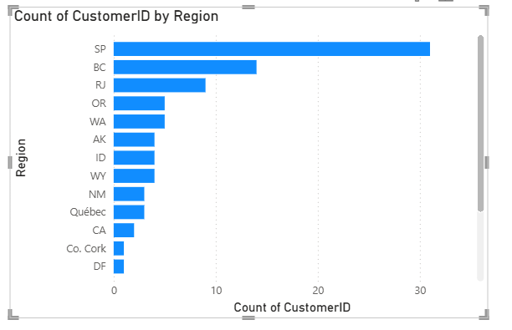

**Analys from the chart that regions wise SP, BC, and RJ have the highest number of customers. Regions such as DF, Co. Cork, and CA have low customers. customer distribution is not equal. Some areas have more customer activity than others.**

**2.What is the trend in customer acquisition over time? Can we create a line chart or area chart to display it?**

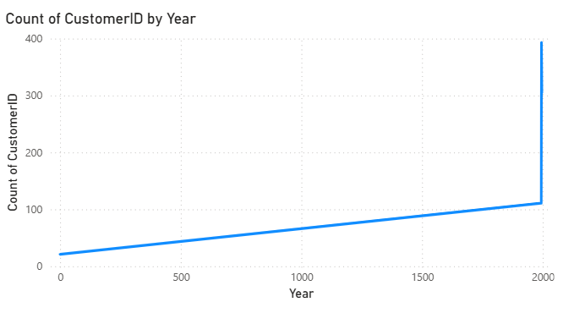

**The line chart clearly shows that customer acquisition was slow in the early years. However, there is a steep increase the 393 customers are increased count around the year 2000. This indicates a strong upward trend in acquiring new customers in recent years**

**3.Can we visualize the distribution of customer demographics such as age, gender, or income?**

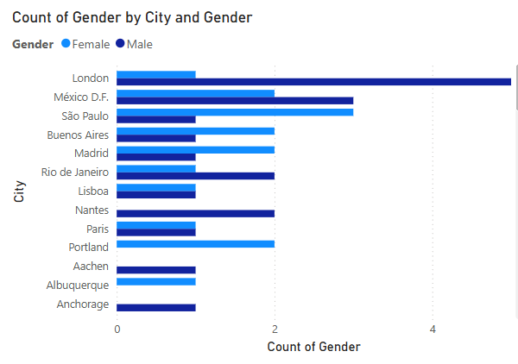

**In this figure London have highest male customers**

**Mexico D.F. and Sao Paulo show a balanced gender**

**distribution, with nearly equal male and female. counts. Some cities like Portland and Paris have only female customers, while cities like Anchorage and Aachen have only male customers.**

**4.How does order volume change over time? Can we create a time series?**

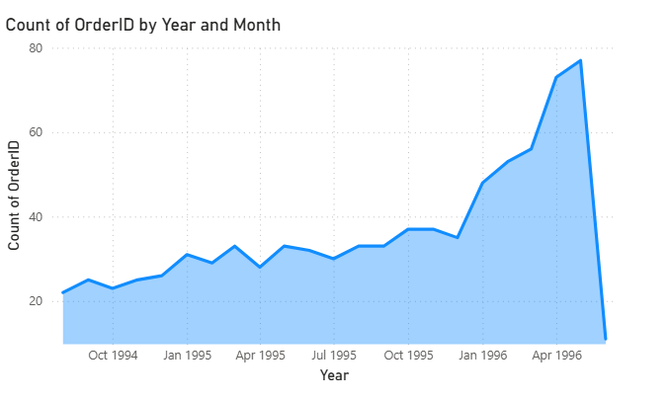

The figure shows the count of orders from 1994 to mid-23 orders. 1996 have Order volume remained steady with small fluctuations until late 1995.From early 1996, there was a sharp increase in order count, peaking around mid-1996, have 77 orders. A sudden drop at the end 1996 to 11 orders.

5.What is the distribution of order values? Can we create a histogram or box plot to display it?

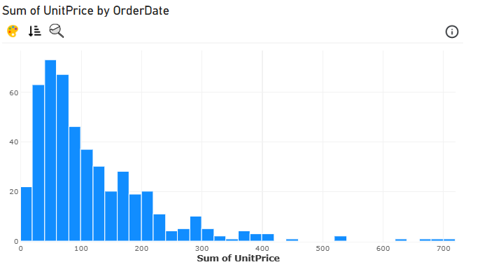

Here the image showing order value based on unit price. The unit is 40 to 59 highest orders are 73 and second highest orders are 67 unit price is 60 to 79. next 62 orders in the unit price of 20 to 39 order value Here the image showing order value based on unit price. The unit is 40 to 59 highest orders are 73 and second highest orders are 67 unit price is 60 to 79.next 62 orders in the unit price of 20 to 39 order value

6.Can we visualize the average order processing time or shipping duration?

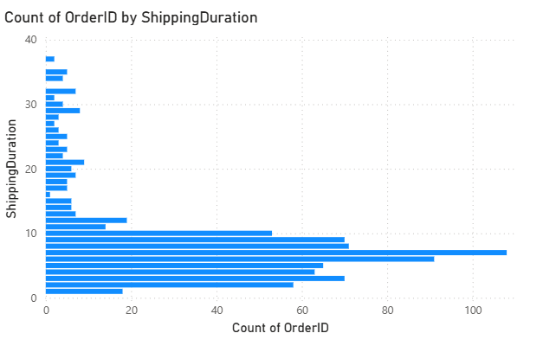

Most orders are shipped within 5 to 10 days, with the peak at around 6 days, suggesting that the majority of orders are fulfilled in under 10 days. There are fewer orders with long shipping durations, indicating efficient processing and delivery for most.

7.How does employee productivity vary across different departments or job roles?

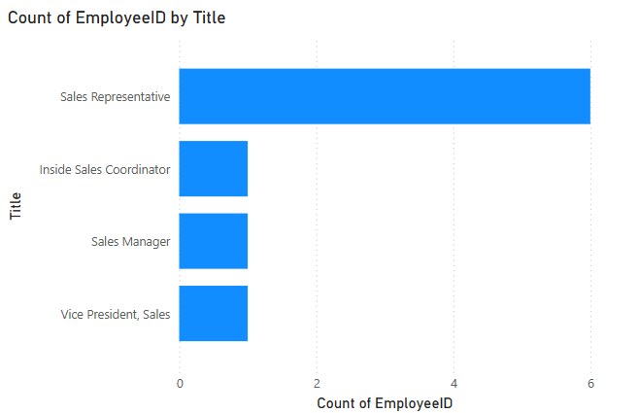

The Sales Representative role has the highest employee count 6, indicating it is the most populated job title in the sales department. Other roles like Inside Sales Coordinator, Sales Manager, and Vice President, Sales have only 1 employee each, reflecting a lean management structure.

8.What is the distribution of employee tenure?

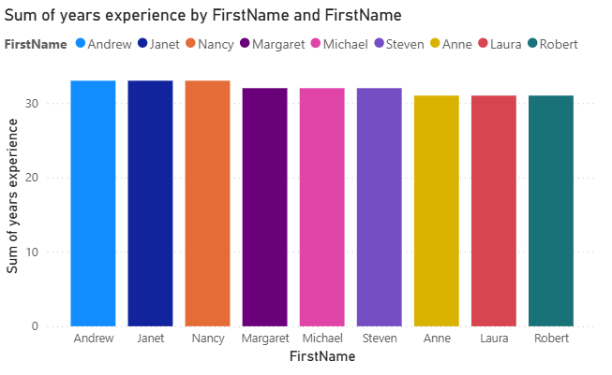

The distribution of employee tenure is around 31 years of experience o Andrew, Janet, Nancy. And 32 years of experience To Margaret, Michael, and Steven.33 years of experience To Anne, Laura Robert. This indicates a highly experienced consistency long-term employee

9.Can we visualize employee performance ratings

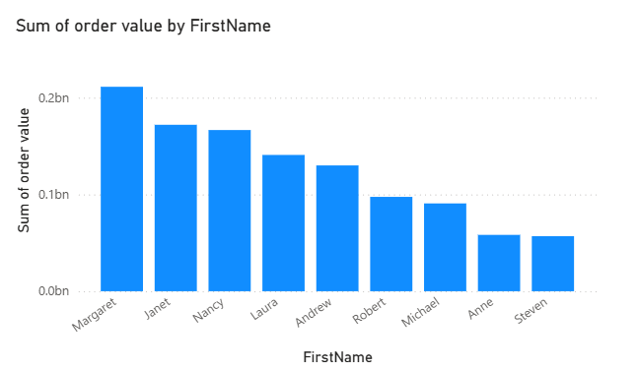

In the figure calculating employee performance rating based on the number of orders handled by employee Margaret leads with the highest order value exceeding 0.2 billion, followed by Janet and Nancy. Steven and Anne contribute the least. This disparity highlights top-performing employees

10.What is the distribution of product ratings or reviews?

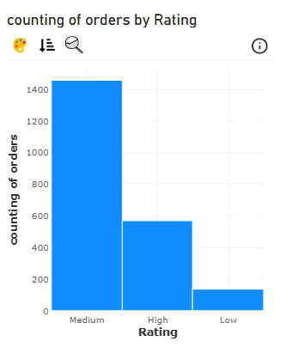

In this histogram chart distribution of products rating based on the counting of orders and rating . The majority of products received a Medium rating, indicating average customer satisfaction. In the medium products have 1400 rating. And in the high rating products have 566 ratings. And lowest products rating have a 110 rating.

11.How does the sales volume vary across different product categories?

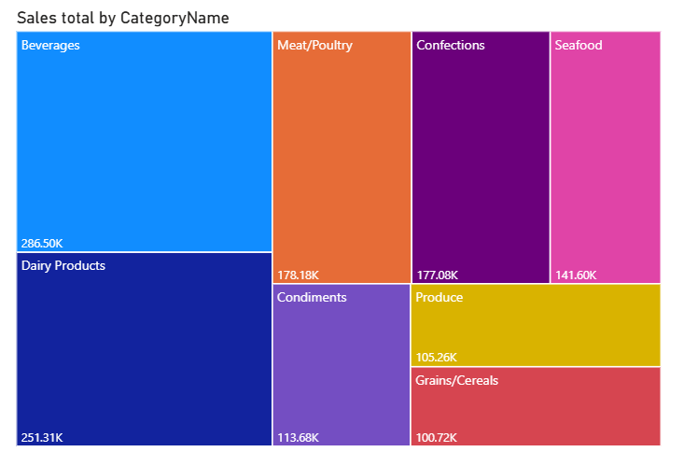

In this Beverages and Dairy Products are the top-selling categories, generating the highest revenue at 286.5K and 251.3K, respectively. Mid-tier performers include Meat/Poultry, Confections, and Seafood, each contributing over 140K. Lower-tier categories like Grains/Cereals and Produce still hold notable sales but may benefit from targeted promotions.

1. 12.Can we visualize the pricing distribution of products?

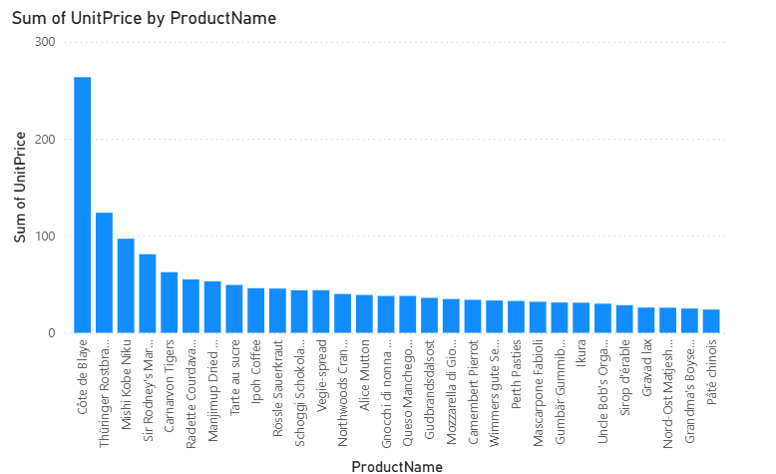

The bar chart shows that Côte de blaye has the highest total unit price by a large margin, indicating it is a premium-priced product. Other high-priced items include Thüringer Rostbratwurst and Mishi Kobe Niku, while most products have significantly lower total unit prices. A box plot or violin plot would better illustrate the distribution, spread, and presence of pricing outliers

13.What is the distribution of supplier ratings or performance metrics?

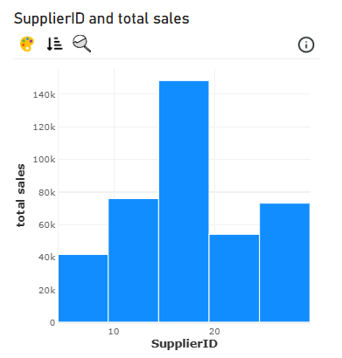

The bar chart shows the distribution of total sales by Supplier id, highlighting variations in supplier performance. One supplier stands out with the highest sales at around $145K, significantly outperforming others. Suppliers with IDs around 10 and 25 also perform moderately well, while others contribute less than $80K. This suggests a few suppliers are key revenue drivers.

14.How does the cost or pricing structure vary across different suppliers?

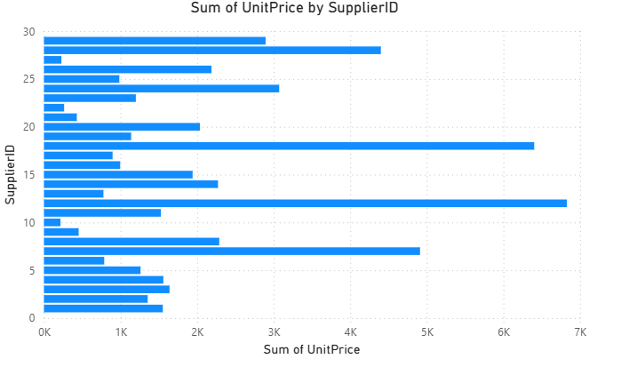

The sum of unit prices by Supplier id, highlighting how pricing structures vary across suppliers. A few suppliers—particularly those with IDs around 12, 18, and 28—have the highest aggregated unit prices, suggesting they provide higher-priced or premium products. In contrast, several suppliers have noticeably lower total unit prices, indicating a focus on lower-cost items.

15.Can we visualize the geographical distribution of suppliers using a map or bubble chart?

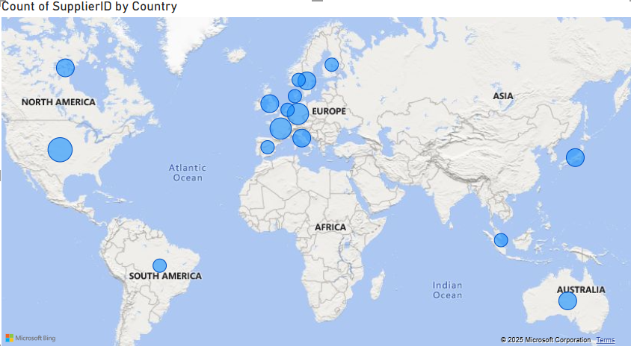

The map shows that the majority of suppliers are concentrated in Europe, especially in countries like Germany, France, and the UK. North America and Australia also have a notable supplier presence, while regions like Asia and South America have fewer suppliers. This suggests a strong European supplier base, possibly due to proximity or product specialization.

Summary:

The Northwind dataset is a classic relational database used for demonstrating sales and inventory systems. It simulates the operations of a trading company that sells food and beverage products around the world. The dataset includes key entities such as customers, employees, orders, products, suppliers, and shippers, all interconnected through primary and foreign keys.

Customers are distributed globally, with each customer linked to multiple orders. These orders are further detailed in the order details table, which specifies which products were purchased, the quantity, unit price, and discount. Products themselves are categorized into groups and supplied by different suppliers based in various countries.

The employees table tracks staff members and their supervisors, forming a management hierarchy. Employees are also assigned to territories within different regions, indicating geographic sales responsibility. Shippers (delivery companies) handle logistics for order deliveries.

In addition, the dataset includes demographic information through customer demographics and customer-customer demo relationships, which can be used for market segmentation. Auxiliary tables like U.S. states and regions support geographic analysis.

Overall, the Northwind dataset offers a rich structure for analyzing sales trends, customer behavior, product performance, and employee efficiency in a retail business setting. It is ideal for learning SQL, data visualization, and relational data modeling.